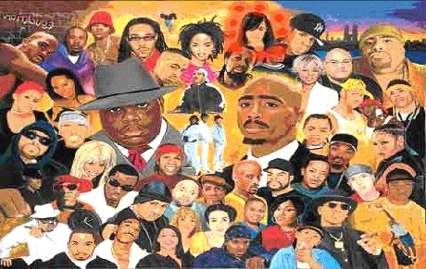  The Greatest!  How did rap music get started?  When block parties got popular in the Bronx, which incorporated DJ’s who played genres of music, especially funk and soul music.  Facts!  - Rapping started out as a street art  - Rap music evolved within 30 years  - Rap started with only African Americans having the ‘privilege’ to rap  - There are two different types of rap  - There are many different flows in the rap game |  |  | 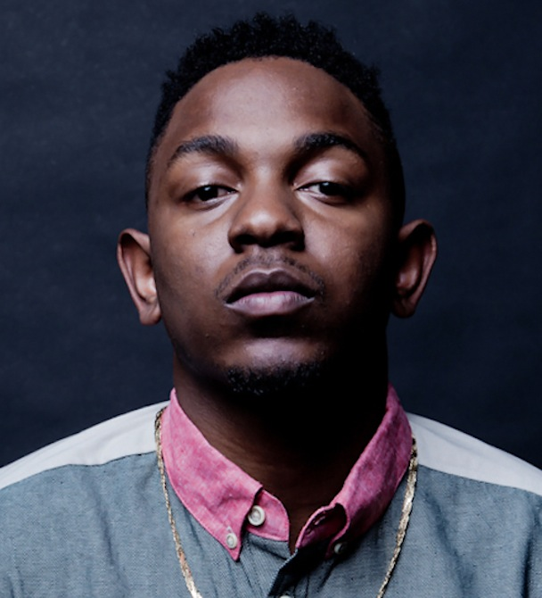  Rappers of today:  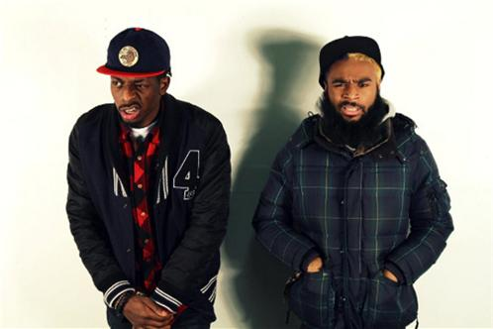  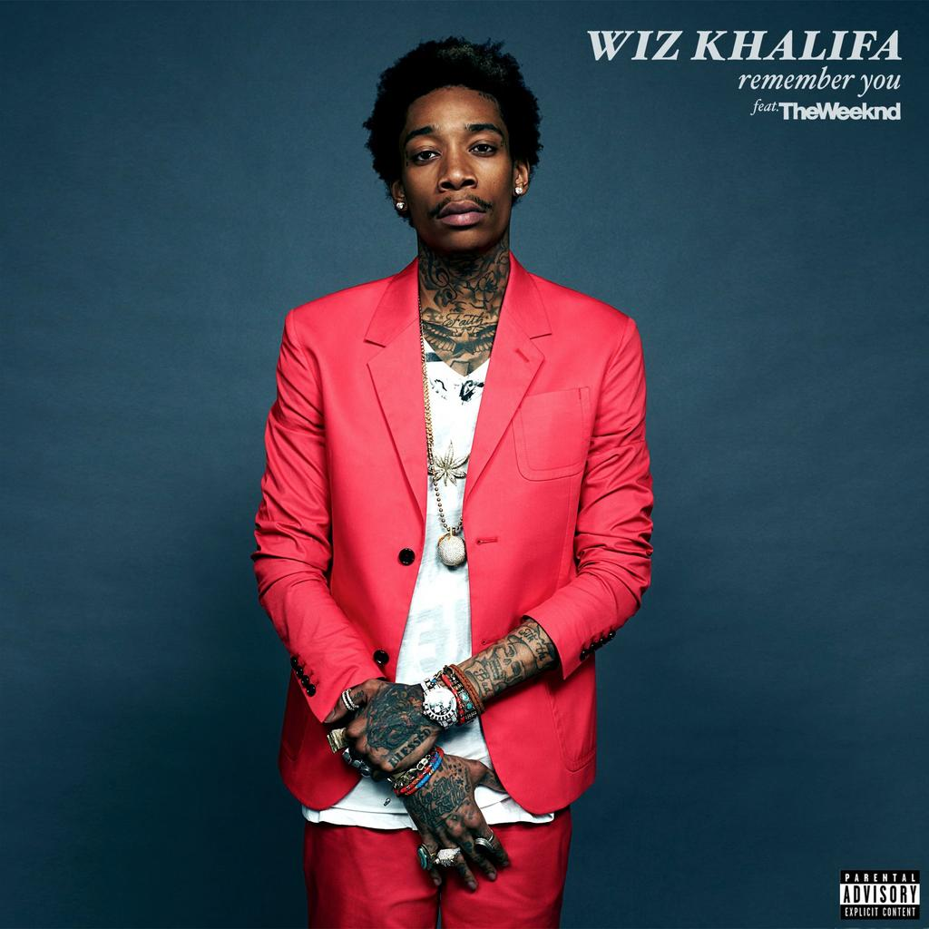 |  |  | Rap Music!  - Consist of chanting rhyming verses which bring joy but hatred to some.

Old school rap!  Old school is based on relatively simple lyrics.  Old school rap is more of a chill type of sound and more kicked back. It was not as hype or exciting as new school but most people prefer it over new school. |  |  | There are some other rap music which is called ‘weird’ music all though people don’t function with it most people enjoy the lyrical verses from some of these guys.  When you’re young not much matters, when you find something you care about that’s all you got, when you go to sleep at night you dream of music, when you wake up it’s the same thing it’s there in your face you can’t escape it, when our young the only place to go is inside, that’s just it, Music is what I love, take that away from me and I really got nothing. |  |  | New school rap!  New school rap is based on louder music and more complex lyrics. My man biggie smalls was one of the greatest rappers of all time with 5 albums dropped. New school music is more of the party music nowadays, with people like juicy J, wiz khalifa, odd future, Danny brown, big Sean, and more being the top rappers in the new school rap game.

